*Structure:

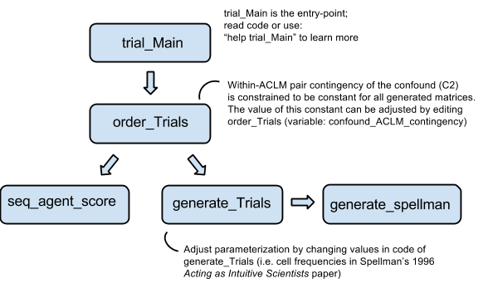

*Notes:

- In short: order_Trials generates trial sequences (by calling generate_Trials, which in turn calls generate_Spellman), and then repeatedly permutes the trials/rows (calling seq_agent_score after each row-permutation to record relevant ACLM pair properties of the given row-ordering). A trial sequence is printed to a CSV file if/when the user-defined ACLM-pair-related constraints are met.

- This code was created by piecing together several pre-existing functions (while documenting the code, I removed most of the artifacts that arose from this process). Since run-time was not a major concern for these original, smaller functions, the present code uses a brute-force approach to generating trial sequences, and is likely suboptimal in several ways (e.g. it should be sufficient for the purposes of the experiment design we’ve discussed previously, but it scales very poorly). One way to make the code a bit more efficient would be to **produce the desired ACLM pairs initially** and then **randomly row-permute the matrix, counting each ACLM pair as a single row.**